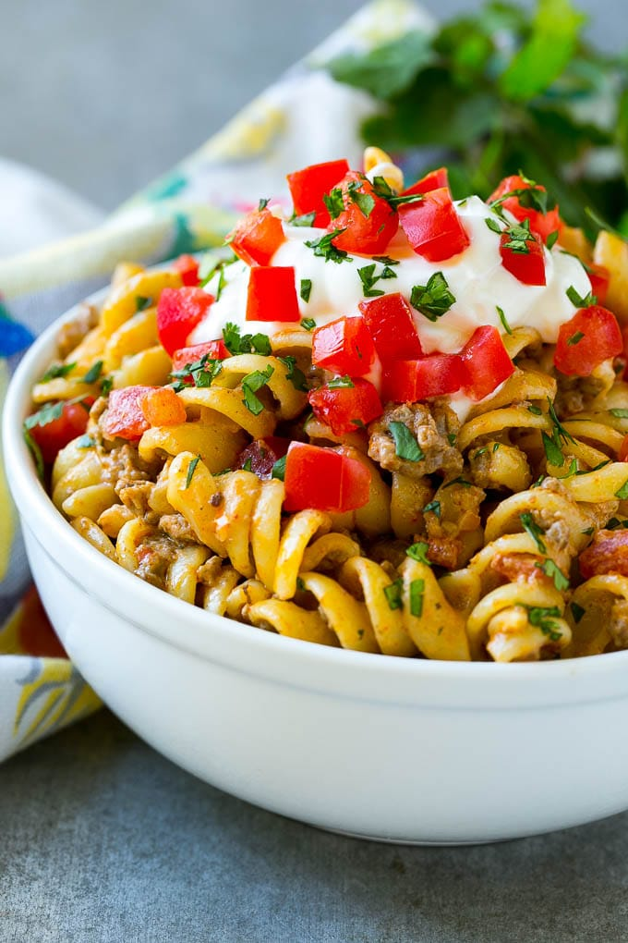
Taco Pasta
Prep time 5 min Cook time 15 min
6 Servings
Ingredients
8 ounces rotini pasta
1 tsp vegetable oil
1 lb ground beef
½ cup onion, chopped
14.5 oz petite diced tomatoes, drained
3 tbsp taco seasoning
2 oz cream cheese
¾ cup sour cream
1 cup shredded cheddar cheese
½ cup diced Roma tomatoes
2 tablespoons chopped cilantro
Additional taco toppings if desired
Directions
- Cook the pasta in salted water according to package directions. Reserve 1/4 cup of the cooking water.
- Heat the oil in a large pan over medium high heat. Add the ground beef and break up with a spatula.
- Add the onion to the pan. Cook for 4-5 minutes or until meat is browned and cooked through, and onion is tender.
- Stir the tomatoes and taco seasoning into the ground beef.
- Pour the cooked pasta into the meat. Reduce the heat to low.
- Add the cream cheese, sour cream and cheddar cheese to the pan. Cook, stirring constantly until cheeses are melted.
- Pour 1 tablespoon of the reserved pasta water at a time if needed to thin the sauce to desired consistency.
- Sprinkle with tomatoes and cilantro and serve. Add additional taco toppings if desired.

